**CHAPTER 8**

**RESULT ANALYSIS**

**8.1 Prediction Results**

The below figure shows the previous closing prices of Reliance Industries (ticker: RELIANCE) listed on NSE India. The red line shows the predicted closing price for the same for the upcoming ten days.

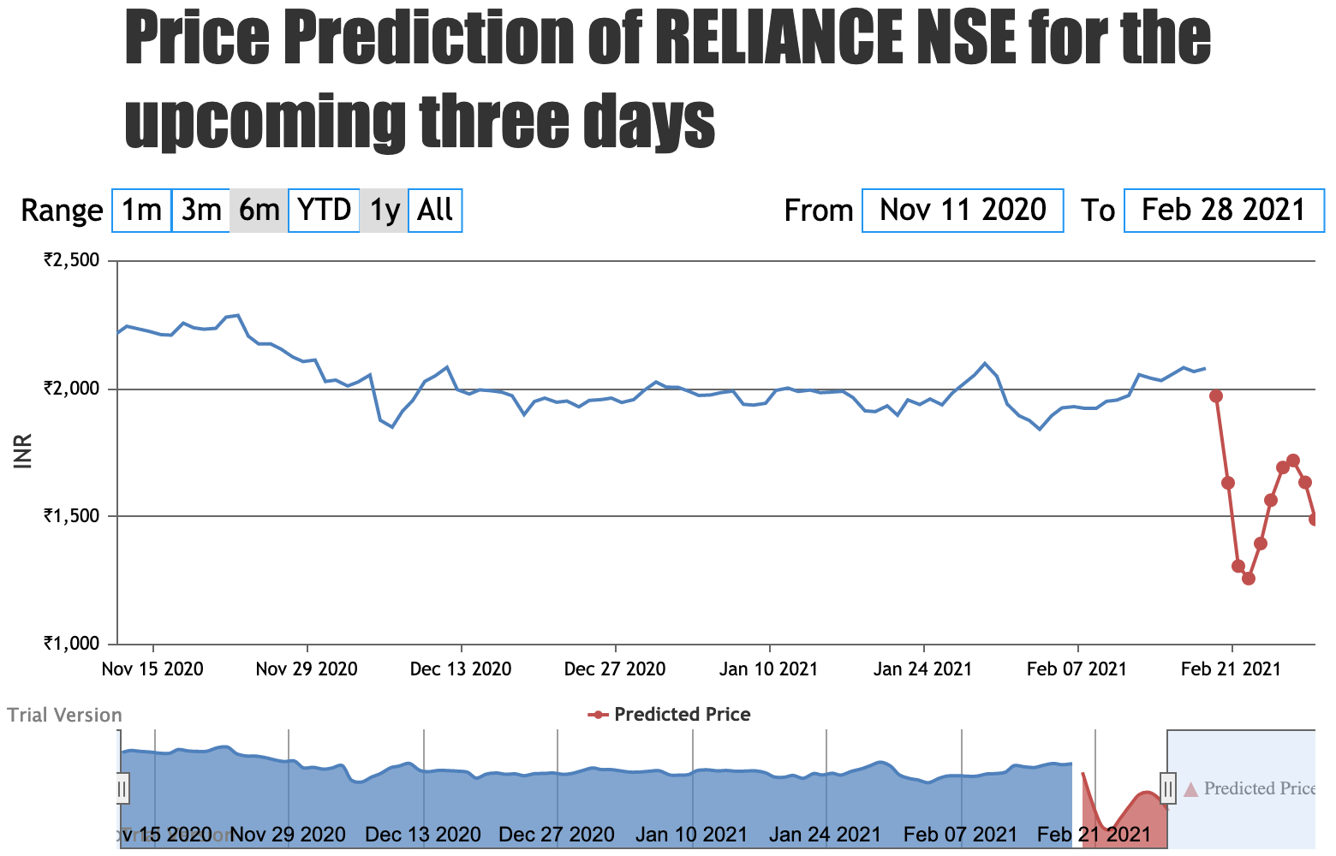

**Fig. NO.** Predicted closing price for Reliance Industries in NSE for the next ten days

The below figure shows the previous closing prices of Vodafone Idea Limited (ticker: IDEA) listed on NSE India. The red dots show the predicted closing price for the same for the upcoming three days.

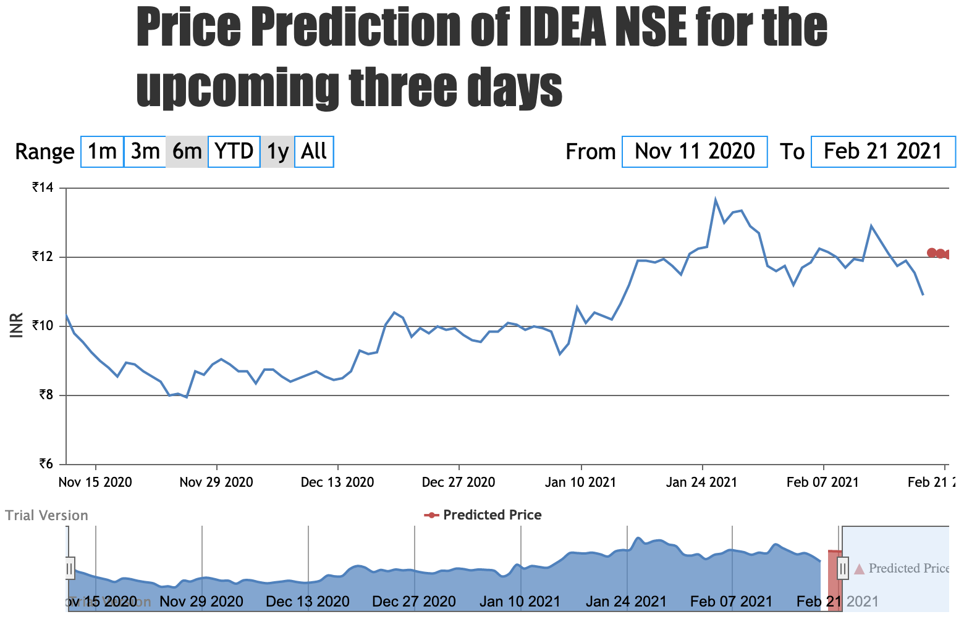

**Fig. NO** Predicted closing price for Vodafone Idea Limited in NSE for the next 3 days

The results show that the performance of CNN-LSTM is the best among the three methods. The forecasts and R2 for CNN-LSTM were 0.90, respectively, increased by 2.8%, 0.55%, relative to the other two approaches namely CNN only and LSTM only.

**8.2 Buy and Sell Signals**

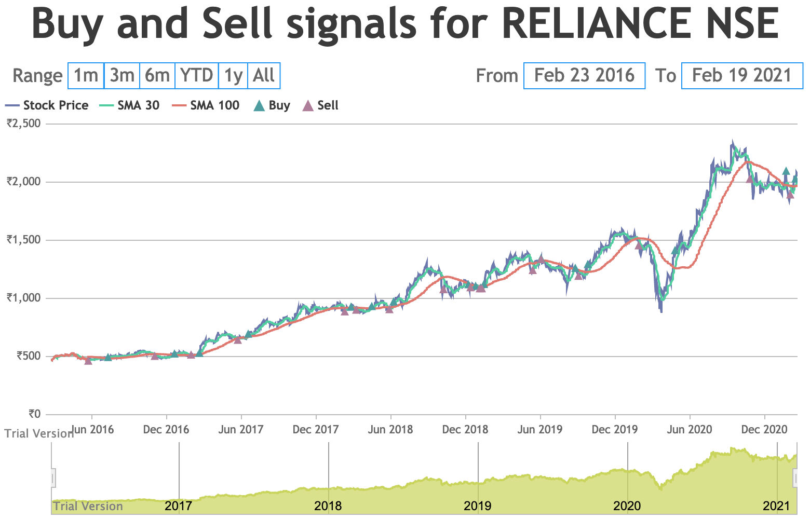

**Fig. NO** Buy and Sell signals for Reliance Industries in NSE

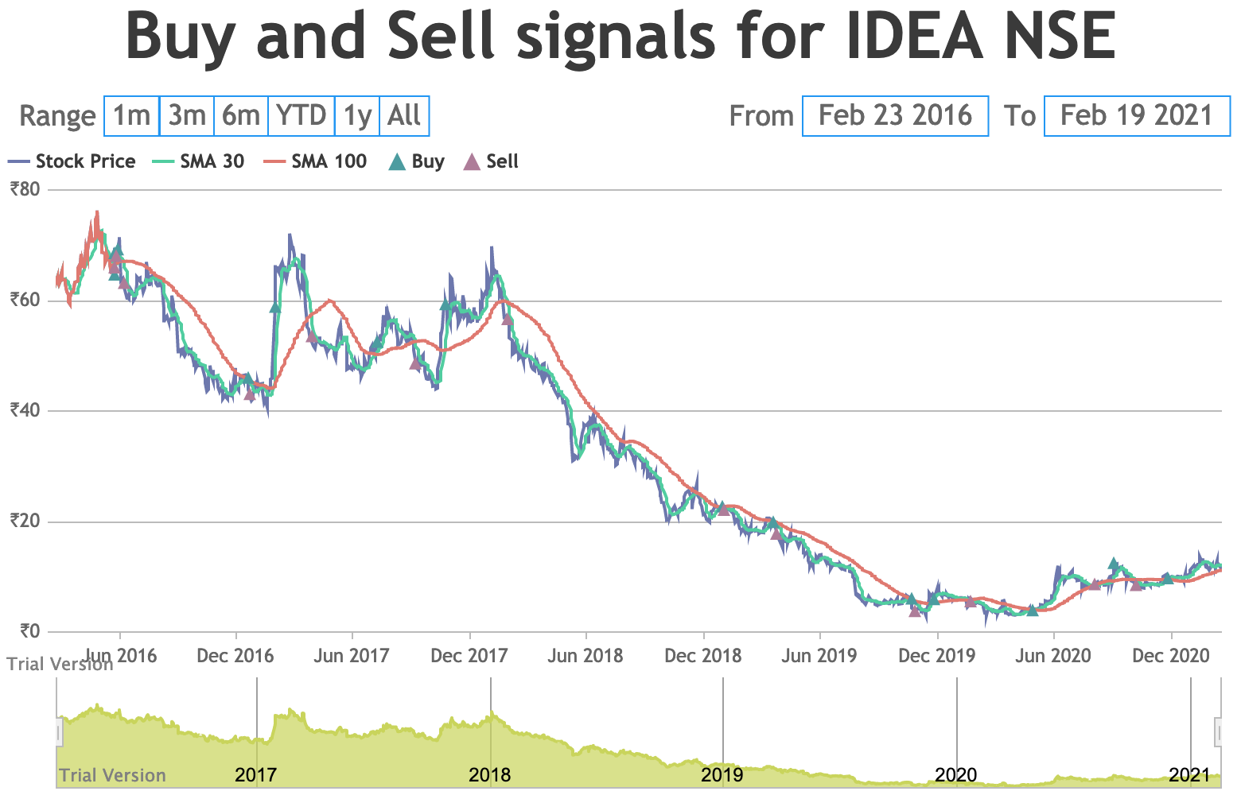

**Fig. NO.** Buy and Sell signals for Vodafone Idea Limited in NSE